Version 1.0

Revision History

|  |  |  |  |
| --- | --- | --- | --- |
| **Date** | **Version** | **Description** | **Author** |
| 02/01/2020 | 0.1 | Initial document | Phạm Nguyễn Hữu Phương |
|  |  |  |  |
|  |  |  |  |
|  |  |  |  |
|  |  |  |  |
|  |  |  |  |

Table of Contents

1. Use-Case Model 4

2. Use-Case Specifications 4

2.1 Use-Case: Login 4

2.2 Use-Case: Booking Tickets 4

2.3 Use-Case: Cancel Booking Tickets 4

2.4 Use-Case: Services 5

2.5 Use-Case: Payment 5

2.6 Use-Case: Report 6

# Use-Case Model

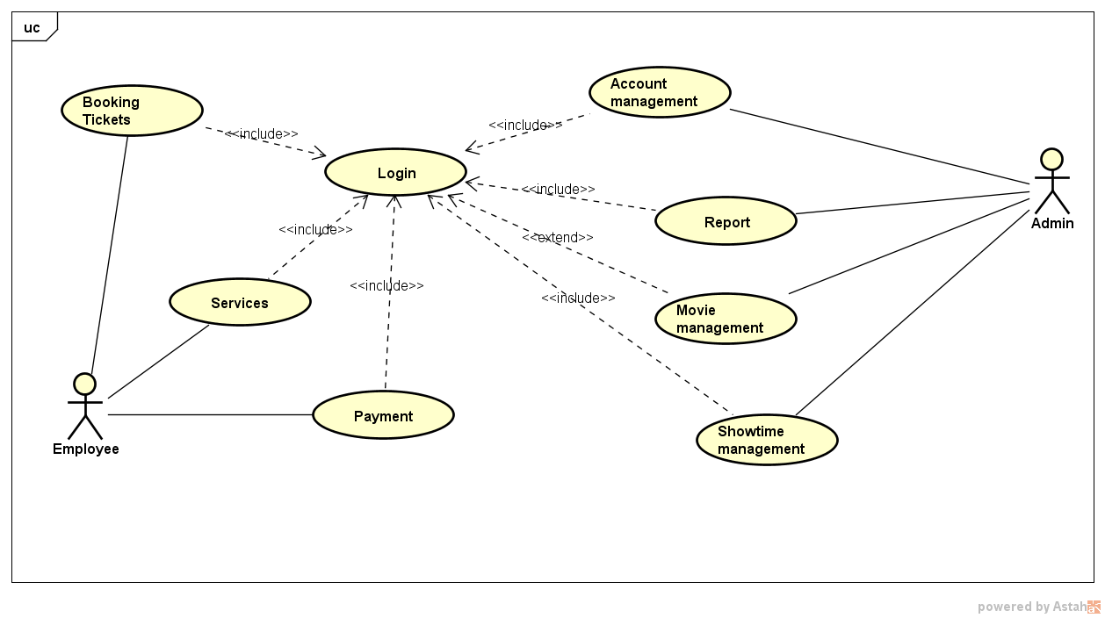

# Use-Case Specifications

## Use-Case: Login

|  |  |
| --- | --- |
| Use case Name | Log in to system |
| Brief description | This use case describes how the User can log in to system |
| Actors | Employee, Admin |
| Basic Flow | 1. At login screen, user input account and password 2. User clicks “Login” button to login 3. System displays the user screen |
| Alternative Flows |  |
| Pre-conditions | User runs application |
| Post-conditions | User successfully login to system and view features |

## Use-Case: Booking Tickets

|  |  |
| --- | --- |
| Use case Name | Book tickets |
| Brief description | This use case describes how the User can book tickets |
| Actors | Employee |
| Basic Flow | 1. At main menu, user selects “Book Tickets” menu item 2. User input booking information 3. User clicks “Book” button to complete 4. System displays the result on the user screen |
| Alternative Flows |  |
| Pre-conditions | User logs in system |
| Post-conditions | User books tickets successfully. |

## Use-Case: Cancel Booking Tickets

|  |  |
| --- | --- |
| Use case Name | Cancel booking tickets |
| Brief description | This use case describes how the User can cancel booking tickets |
| Actors | Employee |
| Basic Flow | 1. At main menu, user selects “Book Tickets” menu item 2. User searchs for the cinema room 3. User searchs for the movie 4. User searchs for the showtime 5. User searchs for the seat to be canceled 6. User selects the seat that the customer wants to cancel 7. User clicks “Cancel seat” button to complete 8. System displays the result on the user screen |
| Alternative Flows |  |
| Pre-conditions | User logs in system |
| Post-conditions | User cancels booking tickets successfully. |

## Use-Case: Services

|  |  |
| --- | --- |
| Use case Name | Services |
| Brief description | This use case describes how the User can add service after booking tickets |
| Actors | Employee |
| Basic Flow | 1. At main menu, user selects “Book Tickets” menu item 2. User searchs for the cinema room. 3. User searchs for the movie. 4. User searchs for the showtime. 5. User searchs for the seat of the customer. 6. User selects the seat to add services. 7. User searchs for the service that the customer wants to add. 8. User selects service item from the service list. 9. User clicks “Add service” button to complete. 10. System displays the result on user screen. |
| Alternative Flows | **Alternative flow 1:** Customer wants to delete service   1. From step 6 of the basic flow, search for the service to delete. 2. User selects service to delete. 3. User clicks “Delete service” button to complete. 4. System displays the result on user screen. |
| Pre-conditions | User logs in system |
| Post-conditions | User checks in customer successfully |

## Use-Case: Payment

|  |  |
| --- | --- |
| Use case Name | Payment |
| Brief description | This use case describes how the User can paying for the customer ticket |
| Actors | Employee |
| Basic Flow | 1. At main menu, user selects “Book Tickets” menu item. 2. User searchs for the cinema room. 3. User searchs for the movie. 4. User searchs for the showtime. 5. User searchs for the seat of the customer. 6. User selects the seat to perform payment. 7. User clicks “Pay” button to complete. 8. System displays the result on user screen. |
| Alternative Flows |  |
| Pre-conditions | User logs in system |
| Post-conditions | User checks out customer successfully. |

## Use-Case: Report

|  |  |
| --- | --- |
| Use case Name | Report |
| Brief description | This use case describes how the User can view reports |
| Actors | Employee, Admin |
| Basic Flow | 1. At main menu, user selects “Report” menu item. 2. User selects “Report” types. 3. User inputs “Duration” field (all dates, between, date and so on). 4. User clicks “View” button to view report. 5. System displays report information on the user screen. |
| Alternative Flows |  |
| Pre-conditions | User logs in system |
| Post-conditions | User views generated report information successfully. |

## Use-Case: Account Management

|  |  |
| --- | --- |
| Use case Name | Report |
| Brief description | This use case describes how the User can manage staff account |
| Actors | Admin |
| Basic Flow | 1. At main menu, user selects “Admin” menu item. 2. User selects “Staff management” button. 3. User searchs for staff information need to be edited or deleted. 4. User clicks “Update” to complete editing or “Delete” to delete staff account 5. System displays account information on the user screen. |
| Alternative Flows |  |
| Pre-conditions | User logs in system |
| Post-conditions | User manage staff account information successfully. |

## Use-Case: Movie Management

|  |  |
| --- | --- |
| Use case Name | Movie Management |
| Brief description | This use case describes how the User can manage movie |
| Actors | Admin |
| Basic Flow | 1. At main menu, user selects “Admin” menu item. 2. User selects “movie management” button. 3. User inputs “movie information” field (title, director, language and so on). 4. User clicks “Add movie” button to complete. 5. System displays movie information on the user screen. |
| Alternative Flows | * + - 1. On step 4 of basic flow, user can select “edit movie” tab to edit or delete that movie.       2. System displays movie that has been edited or deleted on the user screen. |
| Pre-conditions | User logs in system |
| Post-conditions | User add movie information successfully. |

## Use-Case: Showtime Management

|  |  |
| --- | --- |
| Use case Name | Showtime Management |
| Brief description | This use case describes how the User can manage showtime of the movie |
| Actors | Admin |
| Basic Flow | 1. At main menu, user selects “Admin” menu item 2. User selects “Showtime management” button. 3. User searchs for “cinema room”. 4. User selects “cinema room”. 5. User searchs for “movie”. 6. User selects “movie”. 7. User searchs for “showtime date” & “showtime hour”. 8. User selects “showtime date” & “showtime hour”. 9. User clicks “Add” button to add showtime of that movie. 10. System displays showtime information on the user screen |
| Alternative Flows | * + - 1. User can selects “showtime information” on the screen that need to be edited or deleted.       2. User inputs “showtime information” that needs to be edited.       3. User clicks “Update” button to edit “showtime” or “Delete” to delete “showtime” |
| Pre-conditions | User logs in system |
| Post-conditions | User manage showtime information successfully. |